HARVELELECTRIC ELECTRONIC STORE

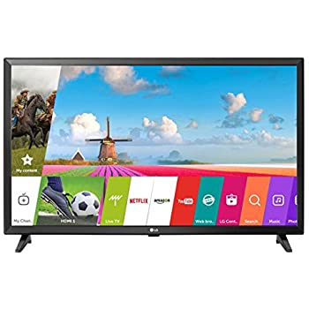

Itel 32" Inch G32 HD Smart Android TV

Brand: [Itel](https://www.jumia.com.ng/itel/)

**Price: $900**

Was ~~$1000~~ 54%

+ shipping only for V.V.I.P clients.

## **Product details**

**32" Inches G32 HD Smart Android TV**is absolutely amazing. It is a smart TV uses the latest android software, android 9.0. Therefore it supports all the app your android 9.0 phone supports.

Its memory size, 1+8g allows you to save movies, music, files etc. in your TV, isn’t that absolutely mind blowing?  Its narrow bezel design ensures your screen is wide enough so you can enjoy your movies, documentary etc. on a wider view.

The chromecast feature allows you to give your phone a wider screen, stream websites and more from your laptop and also mirror your phone or tablet to your TV.

To give your phone a bigger screen, tap the Cast button in any compatible app to enjoy your favorite apps on your TV. You can control what you see from your Android device or iPhone.

 To mirror your android gadget or tablet to your TV, look for the Cast Screen button in the navigation menu. You can use your Chrome browser to enjoy videos, photos, music and other content on your TV. All you need to do is to click the Cast button in your browser and select your Chromecast devise.

The 20 watts stereo sound makes you feel like you are in a cinema. You get to hear and enjoy quality sounds from movies and music of your choice.

Unlike the panels of most TVs in the market, this TV has **A+ Grade Original Panel**. This means that the panel is of the highest quality you can get in the market and so you won’t have keep going in and out of a TV repairer’s shop to fix it. In fact, when you buy this TV, you are buying peace of mind.

Warranty is 12 months.

Redeem warranty in any CarlCare center in Nigeria.

## **Specifications**

## **KEY FEATURES**

* Narrow bezel design
* Powerful CPU & GPU
* Large Memory 1+8g
* Build-in WiFi & Bluetooth 5.0
* Wide Voltage design
* HD
* HDR PQ Technology
* HLD PQ Technology
* Stereo speaker
* Build-in Boomplay Music
* Supported External Audio System
* Android 9.0
* Works with Google Assistant
* Built-in Chromecast & Air Play
* Built-in Google play store
* Support smart source

## **WHAT’S IN THE BOX**

* Itel 32 inches G32 HD Android TV
* Manual
* Stand and Screw
* Remote control
* Batteries

## **SPECIFICATIONS**

* **SKU**: IT724EA0UTGKRNAFAMZ
* **Product Line**: Itel Official Store
* **Model**: Itel G32 TV
* **Production Country**: China
* **Size (L x W x H cm)**: 79 x 11.8 x 49
* **Weight (kg)**: 5.3
* **Color**: Black
* **Shop Type**: Harvel Electronic Store